Introduction To Robotics
What is a robot?

The Webster defines a robot as
An automatic apparatus or device that performs functions ordinarily ascribed to
humans or operates with what appears to be almost human intelligence.

The Robotics Institute of America defines a robot as follows:
A robot is a reprogrammable multifunctional manipulator designed to move material,
parts, tools or specialized devices through variable programmed motions for the
performance of a variety of tasks.

Some history

The term “robot” has its origins in a Czech word “robotnik” meaning worker
It was first introduced by the playwright Karel Capek in a 1920 play. The robot theme was popularized by Isaac Asimov in science fiction in the late 1940’s and the early 1950’s, and subsequently by Hollywood movies.

Mechanization and automation can be traced back to the industrial revolution. The first example of complete mechanization dates back to the development of Jacquard looms (named after the silk weaver Joseph Maria Jacquard) used in the silk industry in France and Italy in the early 19th century. These looms could be mechanically reprogrammed to produce different patterns. However, these looms were simply
machines. There is no notion of “intelligence” that is built into these looms. Further, the process of programming could be very tedious, particularly for complex patterns, and had to be done manually.
The next 100-150 years saw many innovative engineering solutions to pressing problems in industry. A rotary crane equipped with a motorized gripper to remove hot ingots from a furnace was developed by Babbit in 1892. Pollard invented a mechanical arm for spray painting in 1938.
The first teleoperator, or telecheric, a device that allows an operator to perform a task at a distance, isolated from the environment that the task is performed in, was developed by Goertz1. It was designed to manipulate radioactive materials. The operator was separated from the radioactive task by a concrete wall with viewing ports. Two handles on the “master” side allowed the operator to manipulate a pair of tongs on the “slave”
side. Both tongs and handles were coupled by multi-degree of freedom mechanisms to allow the operator dexterity in manipulating the tongs. In 1947, the first servo-controlled electric-powered teleoperator was developed. The slave side did not have to be coupled to the master side. Instead, the movements on the master side were measured by sensors and
used to drive the electric actuators on the slave side.

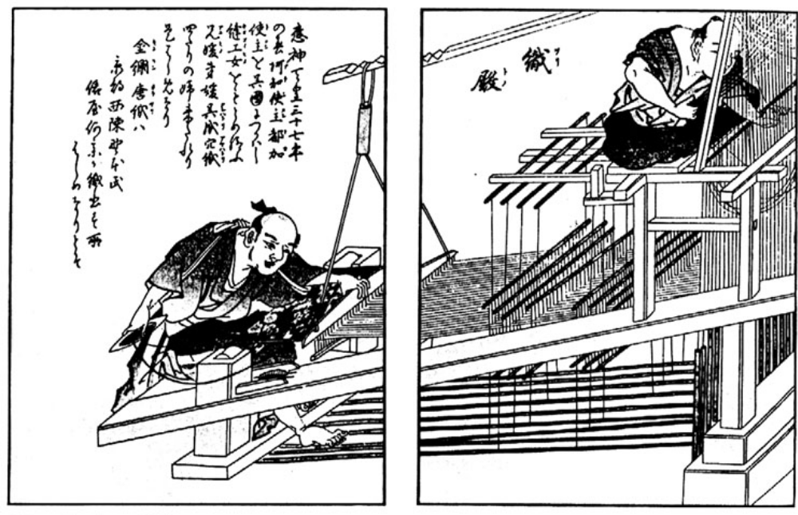

Figure 1 The Chinese drawloom allowed the weaver to program weave patterns.

Around this time, the first large scale electronic computer (ENIAC) was build at the University of Pennsylvania (1946), and the first multipurpose digital computer (Whirlwind) solved its first problem at MIT. The first numerically controlled machine was also the first time that the servo-system technology was combined with digital computers. This first machine was demonstrated in 1952.
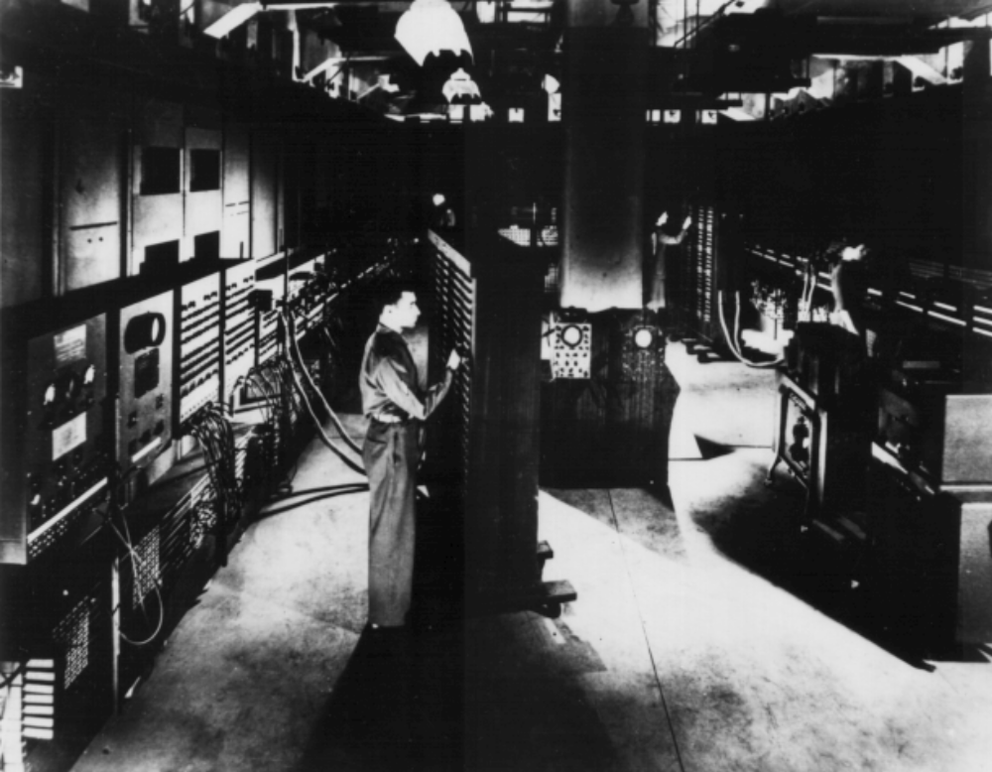

Figure 2 The Electronic Numerical Integrator and Computer (ENIAC)

The robot age began with the demonstration of the first manipulator with play-back memory by George Devol in 1954. The device could exhibit repeatable “point-to-point” motions. Five years later, the first robot that eventually led to the first industrial robot was developed. The first industrial robot was developed by Unimation Inc. It combined the playback features of numerically controlled machines with the servo-control technology
and the articulated mechanisms of teleoperators. In 1962, General Motors installed the first Unimate robot in a die-casting application on one of its assembly lines.

The 1960’s also saw work on developing walking machines using the same
technology. In 1967, Ralph Moser from General Electric developed a four-legged vehicle with funding from the Department of Defense. The vehicle was operated much like the electric teleoperators of the late 1940’s. A human operator would control handles (at the master end) to coordinate the multiple joints at the legs (the slave end). The coordination
task was very tedious, and the problems associated with stable walking were never quite resolved. In 1983, Odetics, Inc., a U.S. company, developed a six-legged device that could walk over obstacles while lifting loads up to 2-3 times its weight. While this vehicle was not teleoperated (in the sense of Goertz’ teleoperators or the GE quadruped), it had to be controlled by a human operator.
In 1985, the first autonomous walking machine was developed at the Ohio State University. The Adaptive Suspension Vehicle (ASV) was a proof-of-concept prototype of a legged vehicle designed to operate in rough terrain that is not navigable by conventional vehicles. It was 3.3 meters (10.9 feet) high and weighed about 3200 kg (7000 lb.). It could be operated in a supervisory control mode (in the same way a human rides a horse)
or in an autonomous mode. It possessed over 80 sensors, 17 onboard single board computers and a 900 c.c. motorcycle engine rated at 50 kW (70 hp). It had three actuators on each of the six legs thus providing a total of 18 degrees of freedom. The 18 degrees of freedom were hydraulically actuated through a hydrostatic configuration. The most important sensor was an optical scanning rangefinder, which is a phase modulated,
continuous wave ranging system with a range of approximately 30 feet and a resolution of 6 inches. It was also equipped with inertial sensor packages consisting of a vertical gyroscope, rate gyroscopes for the pitch, roll and yaw axes, and linear accelerometers to provide information to determine body velocity and position.
The ASV, unlike its predecessors, was completely computer controlled and
independent except for the operator. The operator performed the functions of path selection and specifies the linear velocities of the vehicle in the fore-aft and lateral directions, and the yaw velocity. The roll and pitch rates and the velocity in the vertical direction were automatically regulated by on-line computers.
In December 1996, Honda demonstrated the Honda Humanoid, a robot with two legs and two arms that is designed for use in a typical domestic environment. The 210 kg. prototype has 30 degrees of freedom. It is equipped with cameras, gyroscopes,
accelerometers, and force sensors at the wrists and feet. It is able to walk around, climb a flight of stairs, sit down on a chair, stand up from a sitting position and lift payloads of 10lbs.

